Instructions

1. Download and install anaconda3 from given link

- link : <https://www.filehorse.com/download-anaconda-64/download/>

- At the stage given in the image below check both checkboxes

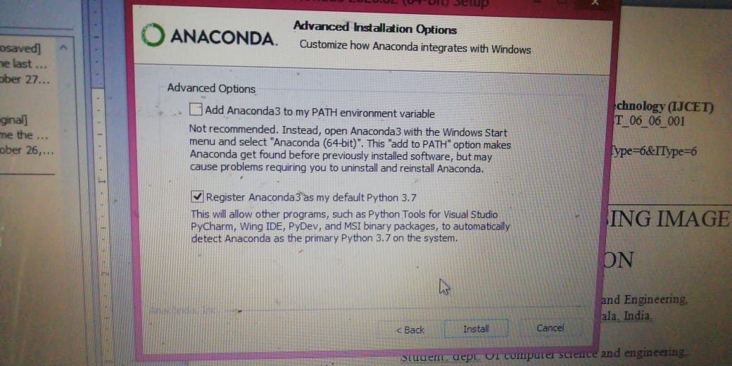

1. Extract “Sign detection.zip” file
2. Extract tf1.zip file to location C->users->user(it may be vary based on your system)->anaconda3->envs
3. Open anaconda prompt in the project1 folder
4. Run command : activate tf1
5. Run command : python manage.py runserver
6. To run sign detection, Open anaconda prompt in ml folder
7. Run command: python finalcode.py